йкпсе



| **Coinage** | **Lifestyle** | **Gold pieces available** |
| --- | --- | --- |
| 0-10 | Simple | 50 |
| 11-30 | Good | 200 |
| 31-60 | Wealthy | 800 |
| 61-80 | Aristocrat | 2000 |
| 81-100 * | Royalty | 20000 |

rom the palaces of the Holy Kingdom to the forests of the Green Pit and the ports of the Confederation, everyone seeks out their place in this world: as a crafts­man, as a soldier, as a spy. The skills of their trade are gradually being refined, but their network of con­tacts and the alliances they made do not always remain sol­id. In Historia, the fickle nature of these ties is represented with the mechanics of Fame.

Furthermore, by carrying out businesses and investing in one’s contacts, there are many possibilities to gather wealth and climb the social ladder. For this reason, there is also a mechanic dedicated to this type of ascent. From the hum­blest slums to the high ranks of the institutions, the bench­mark is always the same: the clinking sound of coins, or as it is called in Historia, Coinage.

*COINAGE*

Redemption, social climbing and acquisition of wealth are important themes in Historia, and they play a role in the game depending on the character’s wealth.

Characters have a specific value of Coinage that identi­fies the amount of resources at their disposal during a chap­ter in the story. Coinage can be used to buy goods, bribe bureaucrats or persuade nobles.

Coinage, however, does not represent a real quantity of coins: it can be a small coffer containing precious stones, some gold bars or an extremely rare metal, even commercial agreements. It is essentially a set of resources to draw upon for a character’s own purposes.

Coinage is a value that ranges between 0 and 100. During an adventure, characters are supposed to have a specific amount of gold coins based on their Coinage value. You can get an additional equal amount of coins by reduc­ing their Coinage value by 1.

You usually begin with a wealth value indicated by your for­tune, and there will be many opportunities along the way to improve that value.

Generally, a successful adventure should reward you with an increase in the value of Coinage equal to 1 or, more rare­ly, an increase in value of 2 if your group has found a way to get paid well above average.

Once you reach a Coinage value of 80, you will not be able to increase it further until you have obtained the top Rank in a Faction or in a career. By doing so, you will in­crease their possessions. Beware, though: holding such vast economic power inevitably draws the attention of many rivals. To stay well and alive, you will need to maintain a network of reliable contacts to watch their back.





NEGATIVE FAME

The world of Historia is not for the weak, and it is certainly not a glorious place where righteousness alone finds a home in the souls of Characters: not everyone is a hero. Characters could also gain Fame from dark, bad, cruel or evil events. In this case, Characters normally acquire Fame points resulting from their activity, but the effect on the people of the continent is filtered through their means: characters who have gained negative Fame will be “feared” rather than “respected”, be “notorious” instead of “famous” and unwanted by high circles, bar those where evil is a precious resource...

Fame can also be considered negative from a relative point of view: great leaders can see their Fame impact them negatively when interacting with a Faction opposite to their own, for example.

*FAME, FACTIONS AND CAREERS*

There are advantages to being the most famous cartogra­pher and explorer of the coast, the most ruthless member of the Confraternity or the most relentless agent of the Confederation : your reputation will always manage to bring you a fair amount of knowledge among the people ■ ■I V esieri.i.

Milestones, heroic or infamous deeds, titles and recom­mendations, can lead you to be known and well-liked in many circles. This kind of reputation is represented by Fame.

In addition to riches, feats that you perform can generate Fame points that you can use to increase your reputation within a Faction. There are typically four Ranks for each Faction, and each Rank is reached after investing a certain amount of Fame points. In addition, reaching a new Rank brings with it different benefits depending on each Faction.

For some Factions, it is also possible to invest part of your wealth to increase their Fame - up to a certain point - or to use your Fame to increase wealth.

The world’s perception of you changes according to your Fame level and can cause various effects. While specif­ic reputation steps are indicated below, Fame needs to be considered as a gradual, flexible and relative path. It is up to the GM to interpret the Fame effect and how this can vary based on where characters find themselves and their personal history. Probably, a remote rural area will have very little outside information, and a person famous elsewhere will be unknown in such places. At the same time, even the residents of a bustling city could show little care for the feats that earned Fame for the character. On the other hand, in a place linked to Characters or teams through which they have accumulated Fame, the effect of that Fame will be much stronger.

Indicatively, your level of Fame is interpreted as follows:

* **Fame 5, Known.** You have accomplished noteworthy feats within your own circle or limited geographic boundaries. Someone may have heard of the you but you would hardly be recognized without due lllll olll.lioll
* **Fame 10, Affirmed.** You have proven your skill, and your name circulates in circles connected to your occupation, earning you respect and acceptance. Your Fame begins to precede you, and you may be recognized even outside of the places you are used to juending.
* **Fame 20, Famous.** You have made headlines far

beyond the confines of your own land and trade, and are welcome even in the highest echelons of society where you enjoy several social advantages deriving from your status: hosting Characters is an honor, artisans want them to use their creations, and they are considered great companionship for important families.

* **Fame 30, Living Legend.** Your name is on everyone’s

lips, your deeds are told with great enthusiasm throughout the continent and you are amongst the most influential people, capable of changing the course of history for a country and beyond.







10 times their Fame value in the Faction to perform the task, they earn 1 Fame.

Completing a career job on behalf of someone with higher Fame, earns 1 Fame.

Establishing a city-recognized career excellence earns you I I'.ime.

Establishing a regionally recognized career excellence earns 3 |jme.

Completing a dangerous task on behalf of someone with higher Fame, earns 1 Fame.

Solving a city-wide problem earns 1 Fame.

Resolving a problem at a regional level earns 3 Fame.

Solving a problem nationwide earns 10 Fame. Accomplishing a great feat earns 3 Fame.

Defeating an opponent with higher Fame earns 3 Fame. Entering a Faction earns 1 Fame.

Successfully completing a mission assigned by a Faction involving a personal risk, earns 2 Fame. Uncovering valuable information, retrieving a rare item or delivering an enemy to your Faction earns 1 Fame. Faction tasks can be performed during downtime. Each time characters spend a number of days equal to

Establishing a nationally recognized career excellence earns you 6 ■ i'.ilne.

Establishing a continentally recognized career excellence earns 10 Fame.

During downtime, you can perform tasks to improve your career. Each time you spend a number of days equal to 5 times your Fame value in your career to perform the task, you earn 1 Fame. Characters can gain fame in this way only while at Rank 0 or Rank 1 of their own Faction or career.

Fame earned in Faction or career activities can only be used to advance within the Faction or career with which that particular Fame was earned. Having a high generic Fame compared to Fame in a Faction or career activity is not, however, useless: characters are considered to be of a higher specific Fame Rank if they have at least one other activity in which they have at least a higher Rank of Fame.

*INVES*T*ING IN FAME*

To progress in a Faction, in a career or to pursue certain Objectives, you need to invest the Fame earned in the cho­sen activity. The total Fame collected by a character remains an absolute value of its own and does not decrease when Fame is invested.

A Fame point can only be invested in one activity, just as Fame resulting from a specific activity can only be invested within that activity.

For example, a Fame point earned for a Faction mis­sion cannot be invested to advance in a career, while Fame earned from accomplishing a generic feat or solving a prob­lem can be invested at will.

*LOSINQ FAME*

Negative, underwhelming or particularly disastrous results cause loss of Fame equivalent to what should have been earned in the same task. Loss of Fame can affect Fame invested in a Faction or Career if characters go below the Fame level necessary to have a Rank, thus losing that Rank’s privileges until they recover enough Fame to invest in those n.livilies.

n Vesteria, factions play a key role and are a fundamental piece of pol­itics and the balance of influence among powers, always working tirelessly to bend the world to their needs and Objectives.

Each Faction follows its own principles, beliefs and modus ope-

*RANK*

randi, often generating long-lasting rivalries. In Historia, factions follow a reputation system that allows you to un­cover secrets and obtain unique rewards.

The faction structure is divided into ranks which represent the different hierarchical positions within the faction. To climb the ranks it is necessary to invest Fame in the rele­vant activity. It is eventually the GM who decides, discuss­ing with the player, if and when it is possible to reach the nexl Rank.

In a Faction it is likely that a Rank is held only by a limited number of individuals. In order for you to advance to that Rank, one of those posts must first become vacant. Another option is that a Faction might require a certain type of behavior and story from its followers in order to achieve a certain role.

The basic requirement for obtaining a Rank in a Faction (except Rank 0) is to have reached the previous Rank, but often there are also other Requirements, narrative or linked to rules, to be acquired in order to achieve a certain Rank.

*CONTACTS*

Joining and climbing the ranks of a Faction allows you to make contacts within it or in some way connected to it. You will be able to make use of said contacts to obtain support, resources, advice, or even to take on assignments and mis­sions destined to the Faction. Continuing within the same Faction gives you access to increasingly important and in­fluential contacts at each new Rank. This does not mean that characters cannot establish further bonds for narrative reasons, but rather that their invested interest in the Faction should translate into acquiring as many contacts, allies and friends as possible within the one group. Obtaining the su­preme contact of a Faction means being in close relation­ship with the top command of the Faction itself, if not even the possibility of aspiring to that post...

*RIVALS*

Nobody can really please everyone. A rival is an NPC within your chosen Faction in direct competition with you. Rivals can pose a “friendly” competition, or feel envy, wish ill or even harbor a deep hatred. Rivals can be openly opposed to you and your exploits or follow parallel experiences that will compare to those of Characters only in terms of results. The rival or rivals are tools in the hands of the GM to give more depth and create interesting narrative twists when playing with a Faction. If GMs feel that a rival is not working, they can decide to set it aside or change it, add other rivals or convert some of them into contacts. It is however recom­mended that there always be at least one rival per character and that the rival always be in a Rank apt to posing an in­teresting opposition rather than a situation that creates an unequal and not very stimulating confrontation.

*FOLLOWERS*

Having a high Rank in a Faction also means having minions ready to follow your orders and perform chores. These are called followers. A follower is an NPC who uses the stats of an opponent of their choice of rank equal to their Rank, with an ideal and bond chosen by the GM or the character if circumstances allow (the bond typically is “I faithfully serve my Faction ”) and a flaw agreed with the GM. The profile depends on the type of Faction to which the follower belongs and is also decided in agreement with the GM. The follower can be used as a resource available to you but is played by the GM in situations where doing so becomes necessary. A follower can stop being a follower if treated in a way that does not follow the principles of the Faction. For followers to deliberately risk their lives for you or for their Faction is by no means a given. A follower can only be replaced where the narrative and the willingness of the Faction to do so are pres­ent. The character can request followers from their Faction or they can be assigned to them. The number, quality and the rank of followers are at the discretion of the GM de­pending on a character’s standing within the Faction and the peculiarities of the Faction itself. Narrative control of a single follower is usually left to the player, groups of followers may be handled by the GM instead.

*RESOURCES*

Each Faction has resources to assist and support its mem­bers. These resources range from economic and legal sup­port to gear and money. The resources available to a char­acter increase or decrease according to the Rank reached in their Faction. What resources are suitable for each Faction is the GM’s decision to make. There must be differences among Factions, as well as different conditions under which they manage their resources. A Faction might bestow its resources in a linear manner, or concentrate them to the higher levels, others may be ready to dispense with little or no notice, while others still could rely on third parties. The narrative development of the Characters’ paths within the Faction should be taken into consideration to show how the supply of resources can grow according to results .

*LEAVINQ A FACTION*

Each Faction has its own rules to respect, rituals to fol­low, traditions to honor, ideals to pursue and objectives to achieve. It may happen that you stop being aligned with one or more of these elements of their Faction, and end up leav­ing it. When you leave (or are forced to leave) a Faction, you lose all perks and any skills they have acquired, including contacts, followers, coinage, and resources. The only thing that remains is their rivals, and the driving force behind what may now be a hostile Faction could be them...

Characters do not recover the Fame invested in the Faction, but if they join another Faction and agree with the GM on the narrative possibilities leading to this new affilia­tion, they may request to join with a Rank just a point lower than the one they had within the previous Faction.

If characters create the narrative conditions to re-enter their past Faction, they can do so at a Rank equal to or lower than the one they previously had, subject to GM dis­cretion, and recover all Fame previously invested.

RANK 0 - NEWCOMER

*COMMON FACTION STRUCTURE*

* Specific Requirements: joined the Faction
* You gain:
* Rank 0 contacts
* Rank 1 initial contact
* Coinage +10

RANK 1 - MEMBER

* Specific requirements: Rank 1
* Fame earned in Faction to spend: 3
* You gain:
* Rank 1 or 2 contacts
* Rival
* Favorable attitude of Faction members
* Rank 0 or 1 followers
* Coinage +10
* Rank 1 resources

RANK 2 - MANAGER

* Specific Requirements: Rank 2
* Rank in the Faction required: Rank 1
* Fame earned in Faction to spend: 15 You gain:
* Rank 2/3 Contacts
* Rank 1/2 Followers
* Coinage +15
* Rank 2 resources

RANK 3 — INNER CIRCLE

* Specific Requirements: Rank 3
* Rank in Faction Required: Rank 2
* Fame earned in Faction to spend: 30
* You gain:
* Rank 3 contacts
* A supreme contact
* Rank 2 or 3 followers
* Each member of the Faction with a lower rank is considered a follower
* Coinage +20
* Rank 3 resources



The Brethren of Worms is a mercenary military organiza­tion, based in a castle built at the eastern end of the Holy Kingdom, but which forms an independent enclave.

Once called Fort Blizzard, it is now known by the nick­name “Worms’ Den”, even by its own inhabitants. The com­mander in charge of the Brethren is Torquato ofTanafonda, the notorious badger leader, and the Deputy to the com­mander is Ranieri De Porcis, a visionary boar and techno­logical genius.

Warriors, mercenaries, soldiers: the members of the Brethren founded by Torquato of Tanafonda are the most

feared threat on the battlefield and on the streets of the cities. Their ferocity is balanced by effective military training and the ability to use firearms, surpassed only by the destructive power of their own muskets. The soldiers and the money needed to

obtain their services flow from the slopes of the mountain to

reach the Worms’ Den, while from the very top of the fort’s tower Torquato is already planning his next move...

The Worms number about 10,000 soldiers scattered throughout the continent, of which 5,000 are stationed at the Hole, and have a small detachment in almost every great city.

*OBJECTIVES*

Earn money through the arms trade, oppose the oppression of slavers, maintain political balance and pursue the wellbe-

*FACTION LOCATIONS*

The headquarters of the Faction is Fort Blizzard, on the eastern mountains that separate Vesteria from the Midlands to the East, but there is at least one branch in each of the great cities of Vesteria except Salso Nero. Over the years, the valley hamlet under the Hole has become a thriving village where the families of the Worms have moved.The Academy of Military Engineers was opened here, where Ranieri is hard at work: in addition to constantly working to improve the Black Powder and its muskets, he is training new engineers for the Worms, as well as a limited number of well sponsored soldiers from all parts of the Continent. Rumors have it that seats are booked for years and years to come.

*WHO CAN JOIN THE FACTION*

Anyone who is skilled with weapons and believes they make for a profitable career. Even if you are a doctor, an accountant, a merchant or an adventurer, the Brethren has use for your services: after all, all organizations need a good bureaucratic and organizational apparatus.

Candidates must be ready to obey a strict hierarchical system of command and rules, as well as having to be courageous and ready for anything for the good of the Brethren. Death is the end that awaits traitors, if not worse.

*HOW TO JOIN THE FACTION*

To enlist, just go to a Brethren detachment, apply, under­go medical examinations and demonstrate a set of useful skills. Joining the Worms means dedicating your life to the cause, and there is no time outside of that spent in the Brethren.

*MANAQINQ CHARACTERS IN THE FACTION*

A Brethren character will have to split between loyalty to their Faction and the interests of the party, given that there exists no distinction between private life and Brethren ser­

vice. Worms are respected across the continent, but they have caused enough orphans to have more than one enemy. A Worm is easily persuaded into a new call, if the wind chang­es, and this can easily put a strain on brothers’ call to decide

where their loyalty lies.

*RANK 0 - RECRUIT*

***Requirements:*** Proficiency in at least one martial weapon, enrolling in a detachment of the Worms, pass medical exam­inations and take an oath of service.

Characters join the Brethren with an oath of allegiance that binds them to the Faction for twenty years. Desertion leads only to death. You are given the official uniform of the Worms and a martial weapon that does not have the aris­tocratic property. The barracks of your detachment becomes



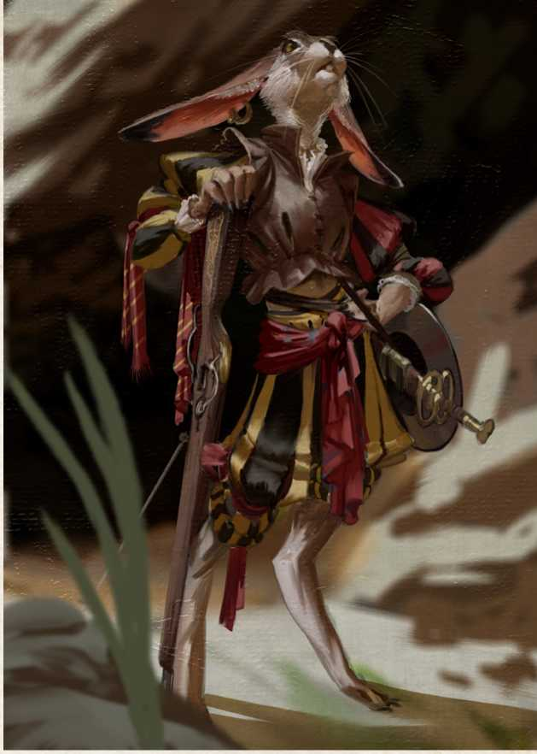

your new home, where you receive food, lodging and care. The tasks entrusted are unlikely to put the you in danger while completing their training as a Worm, but war is a ter­rible necessity and there is no guarantee you won’t be called to duty at any point.

*RANK 1 - BRO*T*HER*

***Fame earned in the Faction to spend:*** 3

***Requirements:*** Have demonstrated ability to perform as­signed tasks, ability to obey orders, discipline and skill.

Characters join the Brethren and receive a fixed salary as well as rewards based on their achievements. After a train­ing period, you begin to be called to participate in increas­ingly dangerous (and profitable) missions, ranging from protection and escort jobs, to presence on the battlefield.

***Special, Well Armed.*** You have access to the Brethren’s ex­traordinary arsenal and have no equipment issues. At Rank 1, you can obtain weapons and armor for yourself that does not have the aristocratic property. At Rank 2, you can get non-aristocratic weapons and arsenal with a +1 bonus, while at Rank 3 you can request equipment with a +1 bonus of your choice without ownership restrictions, including one piece with a +2 bonus. Followers of Rank 1 or higher who belong to the Brethren can also enjoy this privilege.

R*ANK 2 - NON-COMMISSIONED OFFICER*

*RANK 3 - WAR COUNCIL*

***Fame earned in Faction to spend'*** 30

***Requirements:*** Having won the trust of one’s superiors, in­cluding Ranieri and Torquato (or whoever may be in their positions), has proven to be relentless on the battlefield and

set them in favor of a side with more gold on the plate. Torquato, however, also looks at his own beliefs, and has

***Fame earned in Faction to spend:*** 15

***Requirements:*** Having survived a dangerous confrontation, having shown tactical skills and effectiveness in war, having shown no fear and having remained faithful to orders, being successful in the assigned missions.

You are nowhigh Ranking officers of the Brethren: you have many responsibilities and many underlings to attend to, training to supervise, and risky missions to conduct. If you are far from the Hole, you become commanders of a detachment, otherwise you begin to spend more and more time in Fort Blizzard rather than in the village. You have an excellent salary and, albeit without privileges, also en­joy excellent support from the Brethren and its resources.

to have completed tasks that are almost impossible.

Characters enter with full rights in the Small War Council of the Brethren of Worms, where only a handful of brave fighters find themselves with Captain Torquato and Deputy Ranieri De Porcis to discuss the strategies of the greater conflicts in which the Worms are involved, as well as their political preferences: more than once they have acted as guarantors of the governmental balances of the continent, but other times they have been those who up­

never accepted to work for Paddath of Salso Nero, hav-

д$ІШГЙ

The most impressive and ancient institution in Vesteria, ca­pable of controlling the spiritual and material destiny of the majority of the population of the continent, and the very foundation of the great Holy Kingdom, it is unrivaled in terms of its number of followers, political weight and military power. The Church of Bones is the essence of the indissoluble fusion of temporal and spiritual powers.

The Holy Kingdom is an entity in itself inscribed in the very concept of the Church of Bones, by the Edict of San Mastino: the Pontiff is both a spiritual and temporal sover­eign, the Occipites have power equal to that of the Dukes and the education based on the dictates of the Canon is edited by the Tarsi in every city.

*OBJECTIVES*

The Cult of Bones and Ancestors is the only acceptable and un­questionable doctrine, and the Church of Bones the only power tion itself obtains maximum benefit from its every action.

to devote oneself to. Every adept who actively participates in the life of the institution must strive to ensure that the institu-

*FACTION LOCATIONS*

The Church of Bones has sanctuaries spread throughout the continent and is the most popular doctrine among the population, relying on a Tarsus that evangelizes the dog­ma of the Canon in every city. In the Holy Kingdom, the Church can be felt in the very air one breathes: each duchy has its cathedral, a physical place of power administered by its select representatives, called to manage the souls, financ­es and armed forces of its paladins and inquisitors.

*WHO CAN JOIN THE FACTION*

The primary requirement for joining the Church is to be­lieve. Being convinced to do it or simulating it by choice are alternatives, but the dedication to be shown remains the same: an iron will, relentless and uncompromising. Faith and the Canon must guide every action of an adept, and following the orders of the Church is as sacred a task as spreading the Cult of the Ancestors in lands where it has not yet taken root. Priests devote their lives to this mission by undertaking an ecclesiastical career and aspiring to be­come a ludex or an Occiput; armigers operate as paladins or arms at the service of the Inquisition, the Mortified can choose to serve the ‘greater good’ by sharing (and often competing) with the inquisitors the tasks of Executores, en­joying the glory of punishing heretics, true enemies of the Church. For those who are well versed in storytelling or the art of coercion (often through violent methods), the most fitting career is that of the Questionatores, terrible and re­lentless investigators and torturers who carry out their dif­ficult task with the knowledge that someone must do it. There is no secret not worth to be acquired to safeguard the power of the Temple of Nochemburg.

*HOW TO JOIN THE FACTION*

To enter the ecclesiastical hierarchy of the Church of Bones, it takes years of education and training under its protective wing, unless you have demonstrated exceptional and extraordinary episodes hinting at nothing short of miracles. Choosing to follow the Path of Bones is an oath that goes beyond mortal and earthly life: a deep, sacred and indissoluble oath (at least from the point of view of the Cult), which binds the character to the most authoritative power in Vesteria.

*MANAQINQ CHARACTERS IN THE FACTION*

The Church of Bones, as any organization based on spiritu­al ideals aiming to govern in a materialistic way, thrives on dualisms and contradictions. Characters resolved on conse- with all the consequences of the choice they end up taking. Should you experience doubt and indecision, all you have to do is choose whether to follow the doctrine or your belief. The Church is a cumbersome presence, which strives to in­fluence every aspect of the life of its subjects as it organizes society according to a rigid scheme of dogmas, rules, laws and rituals to be scrupulously followed. The Church can also

crating their lives to the Church may find themselves having  
to choose between the earthly Institution and spiritual Faith,

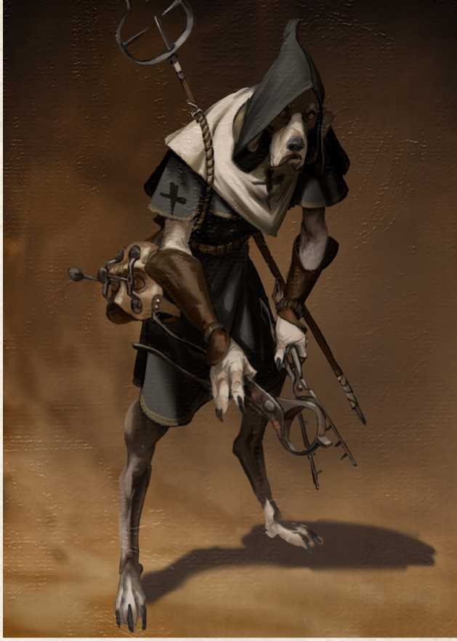

*RANK 0 - FAITHFUL*

*RANK 1 - TARSUS*

become an element of strong confrontation between play­ers with different opinions regarding the true intentions and goodwill of the institution.

Requirements: Swearing an oath to the Church on complet­ing seminary or to an affiliate such as the Order of Paladins or the Inquisition.

You vow to serve and follow the Church until all is left of your body is your bones. The Church welcomes you in its ranks, making its facilities available to you; you can now find shelter in shrines, protection in barracks and ears ready to lis­ten among Inquisitors. Your dedication and spirit will be the meters by which your potential will be measured, whenever simple services are required for the Church.

***Special, Grow Like Bones.*** If you invest in the Church of Bones without being a priest, you receive the standard bene­fits of the Faction depending on the amount of Fame points invested, corresponding to that Rank and not the Rank actu­ally obtained, up to Rank 2. The Church has several branches, such as the Order of Paladins and the Inquisition, where you can prove yourself to be a true believer without necessarily having to rise to power that is in itself spiritual and unattain­able... or is ii?

***Fame earned in the Faction to spend:*** 3

***Requirements:*** Being a priest. Proof that the commitment and the oath made are as hard as Bones.

You become an effective member of the ecclesiastical or­ganization and are appointed Tarsus, a priest in charge of a community or city parish where you exercise a discrete au­thority and influence. You must continuously work for this community or the Rank is withdrawn. You must report to the area Ribber.

*RANK 2 - COSTOLARES*

***Fame earned in Faction to spend:*** 15

***Requirements:*** Have demonstrated total alignment with the thinking and policies of the Church of Bones and have shown leadership and steadfastness of spirit.

You are now the head of a congregation of churches or the diocese of a large city. Your influence and power increas­es, granting you support from your Occiput and the ability to request military and political reinforcements to manage Chur h aHairs.

*RANK 3 - OCCIPUT*

***Fame earned in Faction to spend'*** 30

***Requirements:*** Having won the support of other Occipites, or alternatively at least one Duke of the Holy Kingdom, and having successfully carried out the management of the di­ocese as Ribber with total skill and dedication. One of the twelve seats must be vacant.

You are elected to one of the twelve seats of the Occipitary Council, where the spiritual representatives of each duchy of the Holy Kingdom give advice to the Keeper of Bones and or­ganize the strategies of growth and affirmation of the Church. Your political power is now equal to that of a Duke and you can count on an organized army under your command, as well as the various resources of the Church. Having become po­litical leaders of great value to the organization, you will now find greater danger to your safety within the organization. The Occipites respond only to the Council and the Keeper of Bones and are in direct competition with each other, especially if there is a Keeper to replace. At the moment, Femur III is strong, albeit old, and still enjoys a lot of support.

'^caffhaa^ntacc

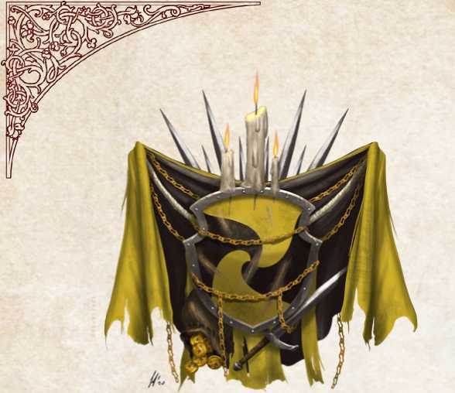ggircfc

The most precious of goods does not travel on wagons, and even just the pocket of a waistcoat makes for plenty of space. Intangible and invaluable, information can become one of the most precious assets in the world if handled in the right way. Indeed, the Circle of Whispers is a shining example of this art. Its members know that a forked tongue is only useful if it whispers the right words in the right ears and is capable of picking out key information from even the most casual of conversations. Information can be a weapon so powerful as to make palaces and villages alike tremble in fear. In a ruthless world like that of Vesteria, where competition between na­tions, families and people has no bounds, everyone wants to know everything about everyone. The mission of the Faction is therefore to profit from this demand for information, with founder Apopi of Whispers sitting at the top of a dense net­work of informants who are handsomely rewarded for every whisper they are able to collect and treasure.

*OBJECTIVES*

The Circle of Whispers aims to weave a web of information so dense that it is almost impossible for anyone to escape. Information is the most valuable commodity in this world, but only for those who know how to use it. Blackmail, pres­sure, rumors and secrets to be kept at a high price are but a few examples of the business conducted by the Circle.

*FACTION LOCATIONS*

The building of the Faction’s founder is located in the city of Calida, in the same place where her first shop was opened, but any city with a large market and seats of power make for a suitable location for a Circle of Whispers branch. In the lands of Vesteria, the crucial location for the Faction remains

Salso Nero, where mayor Paddath is one of the most faithful and loyal purveyor of whispers.

*WHO CAN JOIN THE FACTION*

Anyone shrewd enough, who understands the value of in­formation and thinks it is possible to turn it into a job is an ideal candidate for the Circle of Whispers. Discretion and secrecy are the most important characteristics for an affiliate, but attention to detail and constant vigilance are also neces­sary skills to get away with intrigue and double-crossing. It is above all merchants and rogues who end up in the ranks of this Faction, but it does not bar adventurers and unexpected figures from concealing the Sign - the tattoo that indicates Circle membership - somewhere on their person.

*HOW TO JOIN THE FACTION*

The best way to enter the ranks of the Circle of Whispers is to discover its existence... and, right after, prove to be a poten­tial asset to this Faction. Alternatively, there is the option of joining following a recommendation from a higher-ranking member.

*MANAQINQ CHARACTERS IN THE FACTION*

A character affiliated with the Circle will always be on the lookout for valuable information. The use of this information will have to be made in the interests of the Faction if you are- to rise through its ranks. Unfortunately, every affiliate has at least one very dangerous secret guarded by Apopi herself, and must therefore be able to play the balancing game without ever leaning openly in favor of, or in opposition to, any entity about which the Circle has an interest.

R*ANK 0 - DISCIPLE*

***Requirements:*** Discover the existence of the Circle or be in­vited by a member.

You learn about the basic mechanics of the Circle of

Whispers. Usually, they do not have relations with the other members and are sent code messages containing indications on small and precise tasks to be performed. Disciples are then rewarded with money for completing the assigned task, with­out ever knowing who delivers it to them.

*RANK 1 - WHISPER COLLECTOR*

***Fame earned in the Faction to spend:*** 3 ***Requirements:*** Becoming aware of a Faction and outside of one’s duties.

You becomes an effective agent of the Circle and are em­ployed in more delicate and difficult tasks. You may be introduced to other members, with whom you can commu­nicate to carry out more complex assignments. You also learn about the existence of a safe haven run by a Circle member, usually a merchant’s shop outfitted with a secret hideout, and can call for help if needed - even if the Circle is not known for compassion and merciful cordiality towards low-ranking members. Upon reaching this Rank within the Faction, you will receive a mark that identifies you as a member, usually a hidden tattoo, called a Sign.

secret useful to the

R*ANK 2 - MAS*T*ER OF SECRETS*

***Fame earned in Faction to spend:*** 15

***Requirements:*** Resolving an unpleasant situation for the Circle

You have become a master in the art of information and es­pionage, and are responsible for a network of lower-ranking informants and must deal with managing the information of a specific area. You are entrusted with important secrets within the Circle.

***Special, Master of Secrets.*** You can spend inspiration to learn an NPC’s secret, even one not directly known, as a result of your underlings’ work, which the GM may decide to play as a flashback. The importance of the secret is determined by the result of an Intelligence (Investigation) or Charisma (Persuasion) check subject to GM discretion. A low result will reveal a minor secret, while a high result will reveal an important or dangerous secret, depending on the NPC’s nar­rative or prominence.

*RANK 3 - DARK CONFIDANT*

***Fame earned in Faction to spend'*** 30

***Requirements:*** To meet Apopi of Whispers and amaze her with y oiir re..iili...

You gain the good grace of the Apopi of Whispers, founder of the Circle and Supreme Master of Secrets, becoming their confidant and personal agent Important resources are dedi­cated to the you and your protection is seen by the Faction, as you can rely on a large number of followers under their direct command. The role, however, also entails great responsibili­ties and expectations: while safe from the outside, the Faction does not tolerate mistakes from its high-level members. If you stand out in this Faction rank, you may ultimately com­pete directly with Apopi over leadership of the Circle.

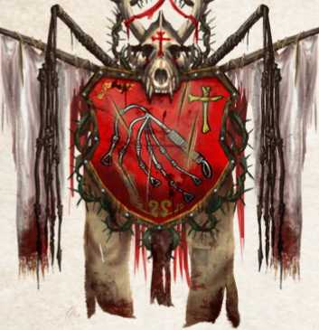,jJOBfrafenifj  
of fit ^Dorftficd

An extremist religious order, the Confraternity believes that the only banner of a sentient soul lies in spiritual detach­ment from material goods and of flesh from bones. A large group with an essentially paramilitary fringe, it is official­ly recognized by the Church of Bones, which has a vested interest in keeping the cult under control: where years of repression failed, annexing the Confraternity made it a re­source for the Church.

Its members are often used as an armed wing in any matter that endangers the Church, but being first of all faithful to their pledges, they can be as dangerous for their targets as for those who give them orders.

*OBJECTIVES*

Spreading the Mortified Philosophy among the population to increase the influence and the dissemination of the creed of the Confraternity, even within ecclesiastical circles.

*FACTION LOCATIONS*

The Confraternity does not have a truly central structure, because it started as an autonomous movement. Now that it has been recognized by the Church of Bones, it has its main branch in Nochemburg where Odo Two Lives resides, appointed as a Faction representative by the members of the Temple themselves.

*WHO CAN JOIN THE FACTION*

Not all the Mortified feel obliged to actively participate in the life and objectives of the Confraternity. Some see the Church of Bones as nothing but a political power that can only distance souls from the search for the Truth of Bones. On the contrary, zealous Mortified are convinced that theirs is a mission of personal salvation as well as a serious call of evangelization. What better candidate than them to grow the ranks of the Confraternity?

HOW *TO JOIN THE FACTION*

To be officially admitted to the Mortified one must under­go the Baptism of Mortification officiated by a member of the Confraternity, usually a Holy One. Since there is no real record of this practice, the number of Baptized in Blood is not very clear, and at the lowest levels of the organization there is real discernible structure: one simply follows the or- to move freely, serving the Faction as you see fit, without necessarily dedicating your entire life to the institution but rather to the cause, unless you intend to climb to the

ders of one’s superiors. Only the high spheres of command of the Confraternity are actively controlled by the Church of Bones: concessions, relics and ecclesiastical acknowledg­ments are among the best tools to harness a Mortified who does not totally despise material goods.

In the non-discipline of the ranks of the Mortified, in­fluential competition in the community or spiritual eleva­tion is a great way to make adepts control each other.

*MANAQINQ CHARACTERS IN THE FACTION*

The Confraternity of the Mortified voluntarily holds loose direct control over its followers thanks to its strong be­lief in the ideals of Mortification; this guarantees that a person linked to them does not sway from the path and

will always act for the good of the organization. If you are  
affiliated with the Confraternity you will therefore be able

top and reach a leadership position. In that case, belief is something more precious than blood and flesh, which is asked in sacrificial exchange for the responsibility and



*RANK 0 - BAPTIZED*

**Requirements:** Having accepted

Mortification

the Baptism of

You officially join the ranks of the sect, from which vari­ous tasks and services will be requested for the good of the Confraternity, often humble and hard work. In return, you will always find solace as well as room and board in the communities of the Mortified.

*RANK 1 - MORTIFIED BRO*T*HER*

***Fame earned in the Faction to spend:*** 3

***Requirements:*** Having shown dedication to the purposes of the Confraternity; having worked hard for the Mortified community to which you belong.

You are perfectly inserted in the mechanisms and life of the Confraternity. You will be assigned tasks by the Church of the Bones and the Confraternity in your role as an operative agent, and participate in various Mortified functions as an active member, even beginning to take novices under your wing.

R*ANK 2 - MORTIFIED SUPERIOR*

***Fame earned in Faction to spend:*** 15

***Requirements:*** Having demonstrated fortitude, solved problems at the Confraternity or offered great service to the Church of Bones, as well as showing great magical skill.

You are now well recognized in the Confraternity and are seen as a guide and role model to follow. You receive several novices to train, who can serve you in their commitments to the Confraternity. You begin to officiate in ceremonies and Mortified processions and are considered blessed by the Bones by lower members of the Confraternity.

***Special, Blind Obedience.*** Your followers belonging to the Confraternity of the Mortified blindly follow your instruc­tions and are fanatically willing to die for them without re­gret. Or at least the true faithful are...

*RANK 3 - VICARIUS MORTIFICATORUM*

***Fame earned in the Faction of spending:*** 30

***Requirements:*** Having established yourself as one of the best Mortified, having blindly carried out the orders of the Church of Bones and achieved great successes against very few failures. Currently, the only place in this position within the Confraternity is occupied by Odo Two Lives.

You have risen among the Mortified as Blessed or incarnate Saints, ready to lead the Confraternity towards the salva­tion of the Bones through the renunciation of the flesh. To occupy this position, however, individuals cannot be naive or foolish; they have to sit in the Rank and be able to look beyond the Confraternity and the affairs of the spirit, heed­ing the directives of the Church whose support is necessary as the role can only be assigned through them... at least until the Confraternity’s, and the Vicarius’, power is fully .■■iroliTimT

From the splendor of his seat, the great Muhur Khan reigns over the Great Eastern Empire with foresight and wisdom. The West is distant but not far enough to be ig­nored, and his gaze often falls upon these strange people as well, waiting for them to be ready to abandon their bar­baric customs and bow their heads before the power of the Khan. The wise and far-sighted Khan knows that he must understand and influence the culture as much as the polit­ical events beyond the White Desert and the mountains, and to do so he sends emissaries to cities and courts so that they can administer his affairs all while increasing his Fame wherever they go.

*OBJECTIVES*

Serve and represent the Khanate, bring every possible bene­fit to the Khan through political friendships and ties.

Only the largest cities have locations recognized as em­bassies of the Khanate, parcels of land granted to the Khan and considered his properties under his laws; such embas­sies are located in Nochemburg, San Mastino, Salso Nero, Nova Marina and Wind Town. Smaller palaces and courts can host emissaries of the Khan to increase their prestige and count on a powerful outside ally; competition usually arises around the possibility of alliances which often re­sult in ruthless political struggles to win the favor of the Khan’s Court.

*FACTION LOCATIONS*

*WHO CAN JOIN THE FACTION*

There are many ways to serve the Khan as an emissary and no good skill ever goes wasted: scholars, merchants, alche­mists, adventurers are all suitable for the role, but there have been magus and soldiers of fortune known to have made their skills available to the Khan.

*HOW TO JOIN THE FACTION*

There are two types of emissary those from the lands of the Khanate who are sent to Vesteria on behalf of the Khan himself, and those born in Vesteria who travel to the Court of the Khan and earn the friendship and respect of those peoples.

*MANAQINQ CHARACTERS IN THE FACTION*

Those affiliated with the Khan will play along the balance between rules, laws and a world they do not fully belong to. Different factions will try to win the trust and support of an emissary, hoping to enjoy the Khan’s automatic favor in case of need. A character born in the Khan’s Empire should be interested in discovering as many things as possible that can improve their position and help the Khanate, while char­acters from Vesteria who find themselves working for the Khan should use their knowledge of Vesteria to better serve their new ally.

***Requirements:*** Belonging to a noble family of the Khanate or having demonstrated to the Khan, or one of his officials, that they can be useful to the Empire in a foreign land.

You are expected to perform simple duties as servants of a higher rank Emissary. Your service to the Khan is not nec­essarily public and can take the form of a minor bureaucrat, observer, or servant to your superiors as you take care of the most disparate but simple tasks. You do not enjoy direct protection but can find refuge in their embassy of reference.

*RANK 1 - EMISSARY*

***Fame earned in the Faction to spend:*** 3

***Requirements:*** Having demonstrated loyalty to the Khanate and successfully performed tasks of above average difficulty.

You are a trusted agent in the Khan’s service, dealing with political and often secret missions entrusted to them by a higher rank Dignitary. You can delegate the Khan’s servants to carry out these missions and can now find refuge and assistance in every embassy.

On becoming an Emissary, you also begin your political ca­reer in the Courts and Palaces, participating as a guest out of friendship with the Khan.

***Requirements:One has*** turned out to be a shrewd agent with you act as the voice of the Khan, representing the Empire and promoting its interests. The support guaranteed by each embassy is great: servants, resources, money - all for the good of the Khanate, of course.

Rank 2 - Dignitary

***Fame earned in Faction to spend:*** 15

strong political skills; winning allies and supporters.

You are a recognized Dignitary of the Khanate and report directly to the Ambassador, taking charge of an adminis­trative area of the embassy. Your political role is active, and

***Special, Diplomatic Immunity.*** Dignitaries cannot be judged by foreign authorities given their direct represen­tative role and emanation of the Khanate itself. You can­not be detained or punished, but you can be confined to

your embassy, with the exclusion of travels to other seats of

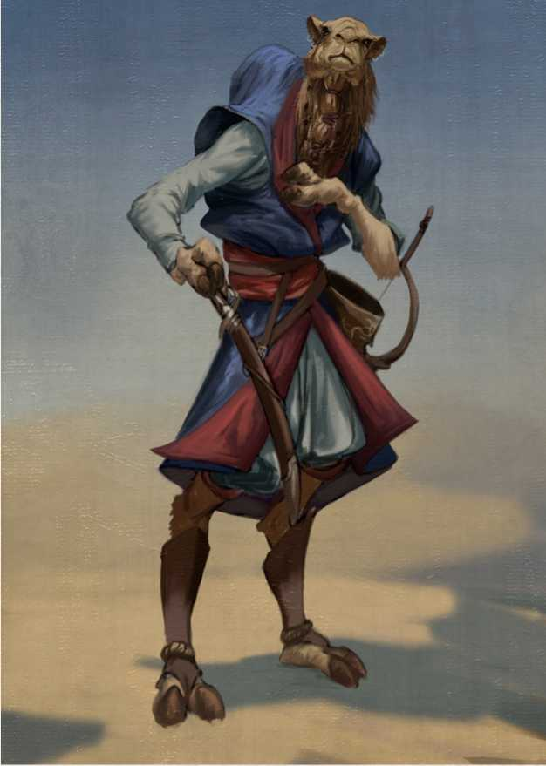***Fame earned in Faction to spend:*** 30

*RANK 3 - AMBASSADOR*

***Requirements:*** Having close contact with the Khan or his inner court, having been successful as a Dignitary. The num­ber of ambassadors is limited to the number of embassies present on the continent, and an existing ambassador’s post must become vacant in order to be filled by someone else.

Each embassy is a small independent ecosystem, in which several emissaries work carrying out a variety of tasks. Embassies also contain a small deployment of imperial sol­diers within its walls.

Every offense, insult to or problem with an ambassador is as if it were directly addressed to the Khan, who is always

ready to lend his support within the available times and shape.

the Khanate or re-entering the territories of the Empire. If your behavior were to bring shame on the Khan or his dominion, the punishment will be harsh and exemplary,

The Fellowship of the Compass is a thriving merchants’ guild that has turned its love for discovering unknown lands and goods into its greatest strength. Originally a group of explorers of the then mysterious western lands, now known as the Confederation, the Faction expanded dramatically when it decided to join a small shipping Fellowship and set out in search of new routes. This communion of intents met with great fortune, not out of chance but thanks to the skill and courage of its members: new routes with the East, the unknown lands to the South, visits to the harsh Northern territories, for a world that is ever expanding, maps after map. Of course, in addition to their passion for adventure, the love of new resources and accruing wealth also contrib­uted to the Fame of the Fellowship, which has been able to

ошрш

о

*OBJECTIVES*

make considerable profits. Having now become one of the most flourishing Factions in the country, the Fellowship is able to influence local and foreign politics, as well as boast­ing illustrious members and important credits.

The Fellowship’s aim is to find and profit from new trade routes to move goods from one part of the continent to another, where few others could venture due to scarcity of means and knowledge.

*FACTION LOCATIONS*

Nova Marina houses the magnificent headquarters of the Fellowship of the Compass, a beautiful white marble build­ing decorated in blue and gold which dominates a large part of the merchant port of the city, including dedicated docks and a rich commercial fleet. Every self-respecting large port has a branch office of the Fellowship, though they might also be present in strategic places in cities not directly on the shore.

*WHO CAN JOIN THE FACTION*

The Fellowship needs arms and minds within its ranks. Anyone who is ready for an adventure that does not exclude profit, can be the right candidate for the Fellowship: mer­chants, adventurers, scholars, but also scoundrels or war­riors, can try their luck with this Faction, travelling by sea and towards unknown lands.

strong motivations and a love for risk-taking: whether one’s motive lies with pure Fame for discoveries or mere thirst for money, the journey that lies ahead is filled with equal amounts of danger and glory.

H*OW TO JOIN THE FACTION*

To become a member, you just need to join through one of the offices as a simple worker, or alternatively as a financing partner, as long as you subsidize the Faction with a large sum of money. The commitment to the Fellowship depends on the type of contract with which one associates, but to climb the top you need to be particularly skilled, driven by

*MANAQINQ CHARACTERS IN THE FACTION*

The Fellowship of the Compass is certainly a good source of employment for the players: missions and jobs of any kind, risk or pay, are assigned daily in the offices of Nova Marina. Thanks to these tasks, affiliates of the Fellowship

***Special, Buy Your Fame.*** The Fellowship of the Compass is based on a system of associates who actively participate in the expenses and dividends of the Fellowship, and for this reason it is possible for a member to “invest” Coinage to be transformed into Fame. This Fame counts only for purposes useful to increase the Rank in the Fellowship of the Compass. A character gains 1 Fame point for every 5 Coinage invested.

are able to bring money and discoveries to the Faction, thus increasing their position - the Faction, nonetheless, will always keep secrets and interests not accessible to all, to be protected at any cost.

*RANK 0 - NOVICE*

***Requirements:*** Register as a worker in a Fellowship office; not be wanted for crimes in the Confederation.

Novices begin working for the Fellowship of the Compass by being assigned to an administrator. You will probably have to board a ship with a very specific, albeit low-level, task.

*RANK 1 - FELLOW OF THE COMPASS*

***Fame earned in the Faction to spend:*** 3

***Requirements:*** Demonstrate the skills, competenc­es, courage and entrepreneurship that are typical of the Fellowship. Leadership and organization are highly sought-after qualities.

You are now a low-ranking officer and recognized member of the Fellowship of the Compass. You begin your career within the Fellowship and may hold various leadership roles on a ship or at a Compass post. Members who prove themselves at this rank of the Fellowship could become Boatswains or even take command of a minor ship in a fleet.

R*ANK 2 - CAPTAIN*

***Fame earned in Faction to spend:*** 15

***Requirements:*** Having completed several trips and profit­able activities for the Fellowship. Additionally, one must demonstrate great skill and a dedicated spirit to command a ll.ig-lilp.

You receive a gold pin depicting a compass as a symbol of your new rank as Captain. You are given a flagship, which could be part of a small fleet, and can ask permission from the Fellowship to undertake initiatives on their behalf, from which the Fellowship will receive part of the profits.

*RANK 3 - QOLDEN CIRCLE*

***Fame earned in Faction to spend:*** 30

***Requirements:*** Having conquered new routes for the Fellowship by making them significant amounts of money, have overcome great obstacles and have proved to be brave and brilliant entrepreneurs.

You become part of the Compass Fellowship Command with a rank equal to that of Commodore. Thanks to this new position, you have the ability to manage the commer­cial policies of the entire Fellowship together with the other members of the Command. You receive a significant por­tion of the glorious merchant fleet and direct income from Unde earnings.

The name “People’s Army” comes from the initiative pro­posed by its founder, Wolfgang Gabrinus, to establish a law in San Mastino that required half of the city army to be un­der the control of an elected People’s Court in order to op­pose the injustices perpetrated by the Church of Bones and the Aristocracy. After the arrest of Gabrinus, the merchants and the people who supported him transformed his idea into a secret but concrete rebellion to demand even more justice. The wolf has been freed from the cage, and now the Confederation has taken command of this movement that is growing day by day, driven by only one well established ideal: freedom!

However, it remains clear that the movement has many detractors both in the Confederation and in the Holy cratic government of the Holy Kingdom in favor of a more modern administration, where the people and the middle

Kingdom, who would gladly do without the presence of a subversive individual like Wolfgang.

*OBJECTIVES*

What the Army aims at is as conceptually simple as it is

almost impossible to achieve: the overthrow of the aristo­

class can be the makers of their own destiny.

For some it is a dream; for most it is nothing but madness.

*FACTION LOCATIONS*

The People’s Army has hidden cells scattered throughout the Holy Kingdom; in particular its headquarters are re­portedly in San Mastino, while the Command is currently located in Montetorto in the Confederation. The People’s Army is always ready to “assist” poor people in destabiliz­

*WHO CAN JOIN THE FACTION*

ing the Holy Kingdom. What the Confederation does not realize is that the “People” are also questioning their meth­ods and their rule, not so different from those of the Holy Kingdom.

If Maria Grazia ‘The Powerful’ only knew about the se­cret cell of Nova Marina...

The People’s Army needs everyone. Its backbone are mer­chants, armigers, sages, rogues and adventurers, eager to change society and the world in which they live, risking their lives against an incredible enemy for an ideal and a feeble hope. Idealists, combative, reckless and resilient, these are the adjectives that describe the activists of the People’s Army.

*HOW TO JOIN THE FACTION*

Joining the ranks of the People’s Army is a voluntary act. Outside the territories of the Holy Kingdom it is easier to get in touch with a representative group and join its ranks, while within the domains of the Church, only whispers and wit, combined with a good dose of discretion, can bring a character closer to a hidden cell that could surprisingly re­veal itself behind any ordinary person.

*MANAQINQ CHARACTERS IN THE FACTION*

The Army can be served with small gestures, as its back­bone is made up of commoners who help as they can, acting as a network of information and offering shelter to spies and exiles, or sometimes secretly moving goods. The actual combatants of the Army are only waiting for the most pro­pitious occasion to strike a well-aimed blow to the estab­lished order. All this must be handled with extreme care: in addition to the lives of the brave few, there is also that of their families at stake. Dissidents who talk about democra­cy make for a dangerous influence, and their children will probably not be viewed much differently.

***Requirements:*** Having close contact with a group of repre­sentatives of the People’s Army.

You may espouse the cause of the Army by joining its ranks and offering your support to the cause. Initially this takes the form of small illegal jobs such as transporting letters, protecting other dissidents and other menial activities, all financed by the wealthy merchants who support the cause. Simple dissidents do not know the identity of most of their comrades in order to avoid information leaks.

*RANK 1 - SOLDIER OF THE PEOPLE*

***Fame earned in the Faction to spend:*** 3

***Requirements:*** Showing faith in the cause by risking ones’ own safety and carrying out a risky task for the People’s Army.

You join the organization by becoming an active member. You know the affiliates of your cell of reference and a direct superior and may be called to action for dangerous missions or invited to proselytize in favorable environments, all the while maintaining your anonymity. Dissidents always help a Soldier in case of need.

*RANK 2 - LEADER OF THE QEN*T*ILES*

***Fame earned in Faction to spend:*** 15

***Requirements:*** Having achieved great results for the People’s Army and having revealed their involvement publicly to win the hearts of new Dissidents, after having achieved an important success.

You are considered a Hero of the Army and one of its key figures, becoming increasingly more important within the organization of the movement and acquiring direct con­trol of a group of People’s Soldiers. The forces in opposi­tion to the aristocratic rule of the Holy Kingdom become your supporters, who turn all your Fame into infamy for the Holy Kingdom.

***Special, Ignite the Soul.*** You are capable of instilling strong emotions in people’s hearts and motivating them to take what is rightfully theirs: freedom! Dissidents love the People’s Courts and are willing to fight, if not die, to sup­port them if asked by one of them. When this happens, Rank 1 NPCs count up higher in the calculation of their hit roll and damage, treating commoners’ improvised weapons as standard ones.

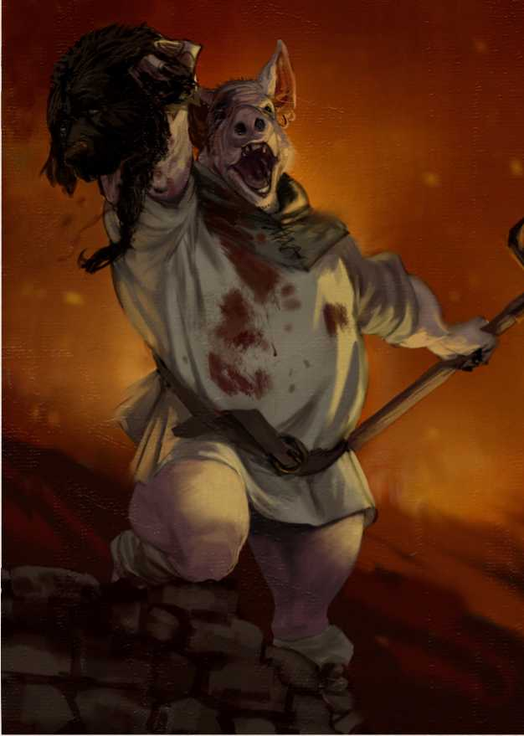***Fame earned in Faction to spend:*** 30

*RANK 3 - COMMANDER OF THE PEOPLE*

***Requirements:*** To forge ties of understanding with a power hostile to the Holy Kingdom, to demonstrate great skills of command and strategy, as well as the ability to draw people.

At the moment there is no formal People’s Commander: Wolfgang Gabrinus, the Tribune of the Peoples, is con­sidered at the head of the movement but has not yet ob­tained the necessary support from a power hostile to the Holy Kingdom to be able to bring the People’s Army closer to achieving its next goal. People’s Commanders count as a political leader in the balance between nations, and for this reason they are in a dangerous position albeit one of great strength. On reaching this status, it will become very difficult to distinguish enemies and friends: understanding whom to trust and the actual resources that can be mustered are among the most difficult tasks for the Commanders of the People, who must also dedicate their lives for the free­dom of the people.

The religion most followed in the cosmopolitan Confederation, based on the teachings of the Order of Indicants, opposes the traditional Church of Bones not on a dogmatic level, but on the management of tempo­ral power. Indicants believe that the Church should not hold temporal power and swear an oath of renunciation of material goods, stripping themselves ‘to the bone’ to re­discover what is sacred in everyone. Lacking a strong cen­tral organization, it is run by a group of Occiput Heretics who administer the souls of the major Confederate cities, whose most important representative is the Occiput of Albea, currently occupying the position of antipope at the head of the Simple Church: Talus II. He is a pug, as was Index IV, despite not being of the same family. This legacy contributed to the affirmation of the derogatory nickname ■ f Pug Heresy.

*OBJECTIVES*

The Simple Church wants to organize itself to increasingly oppose the Nochemburg Church, guiding a greater number of souls towards a just and measured life, without falling into the degenerate excesses that characterize its ancient counterpart. The election of a true antipope and a strong evangelization in new territories are the current main pre-

*FACTION LOCATIONS*

The seat of the Simple Church is in Albea, in the Confederation, where the Cathedral of Saint Catonice of Twilight, the main temple of the Pug Heresy and place where the relics of the Saint are kept along with the bones of the small paw of Index IV. There are several other im­portant sanctuaries, abbeys and monasteries that preach the Simple Doctrine scattered across the Confederation and rural areas of the Green Pit, but nothing comparable to the churches of the Classical Doctrine.

*WHO CAN JOIN THE FACTION*

The Pug Heresy has a purely spiritual mission: it is not so belligerent as to need armies, it is not so intolerant as to have an Inquisition, it is not so extreme as to accept fanat­ical deviations. For this reason, it is mainly composed of priests and scholars who practice and discuss the Simple Doctrine of Indicants.

*HOW TO JOIN THE FACTION*

To serve the Simple Church it is necessary to undertake a spiritual journey made of reflection and renunciation, charity and service, and a good dose of duty and sacrifice against the current that powerfully pulls you towards the glories of the Classical Doctrine: resources, power, and the fear it inspires with its armed forces and inquisitors. To begin your career within the Pug Heresy you need to take your vows in an affiliated order or sanctuary with the Stripping Ceremony, in which you renounce all your material possessions.

*MANAQINQ CHARACTERS IN THE FACTION*

The Pug Heresy would appear to be a cleaner and better version of the Church of Bones, in which the main inter­ests are to deal with spiritual problems and have a humble standard of living, but maintaining a Church still holds a high cost. Corruption is always just around the corner and innocence is often confused with naivety in a young insti­tution called to discuss ancient and timeless topics. Indeed, not all its ecclesiastical members have converted from the Classical Doctrine out of pure spiritual needs. Characters who choose to undertake the path of the Simple Doctrine should explore these themes, eventually taking part in the choices that will form the backbone of this new Church.

Characters who come from the Holy Kingdom and develop an interest in the theses of Index IV and the Heresy will have to constantly look over their shoulders...

*RANK 0 - STRIPPED*

Requirements: Attend a Stripping Ceremony and take an oath at the Simple Church.

You will begin your service as a priest or deacon of the Simple Church, abandoning all material possessions. You will have to perform various tasks and services for the good of the community to which you belong, often menial and hard work. However, you can always find refuge, food and lodging in the structures of the Simple Church.

*RANK 1 - SIMPLE TARSUS*

***Fame earned in the Faction to spend:*** 3

***Requirements:*** Being a priest. Serving your community with dedication and following the Simple Doctrine.

You become a leader of a small Indicant community. You are in charge of children’s education and supporting activ­ities, and must continually work for the community or the Rank may be withdrawn.

***Special, Salt of the Earth.*** The humblest people are the very foundations on which the Pug Heresy rests, motivated and dedicated as they are to a doctrine that puts them on the same level as the rich and the powerful. If the Simple Church lends support to one of its members, that mem­ber is sure to receive back in equal measure: you can always count on the support of the rural and poor communities living in symbiosis with the Faction. Stripped of its glories and excesses, the Church also manages to draw individuals from higher social statuses.

*RANK 2 - SIMPLE COSTOLARE*

***Fame earned in Faction to spend:*** 15

***Requirements:*** Gaining the support of influential and powerful resources for the sake of the Simple Church and acting in the interests of the community in the role o| l.irsus.

You are now responsible for a group of small commu­nities or a city community that placed trust in you, and on whom you can rely in case of need. The Cathedrals of the Costolares are financed by wealthy faithful who be­lieve that the salvation of the soul, and making a good impression on the community, count more than money. City administrations of the Indicant communities must necessarily come to terms with the Simple Church, and for the good of the community itself they have an interest in making it a fruitful collaboration for both parties.

*RANK 3 - SIMPLE OCCIPUT*

***Fame earned in Faction to spend:*** 30

***Requirements:*** Having transformed a Rib into a thriving

basin dedicated to the Simple Church to the point of mak­ing it necessary to establish a new Occipitary, or alterna­tively replace an Occiput after having proven to be a great Ribber by winning the support of a governor or an Occiput.

The Occipitary Council of the Simple Church is more flex­ible than its counterpart of the Holy Kingdom, not being limited in number but rather in continuous development. At the moment it is made up of only four members, each lead­ing the only communities large enough to justify an Occiput: Albea, Nova Marina, Wind Town and Liveccia. This council is the strategic fulcrum of the Simple Church and is directly supported by the Confederation and by enemies of the tra­ditional Church, relying on their numbers and resources. At the head of the council there is Talus II, Occiput of Albea. It is said that Talus II used to be an incredible and generous figure for the Church, but that with the passing of years he became hungry for fame and a little too attached to materi­al goods and reliant on strong political support, which may have to with his easily malleable nature.

(L

frlMrfe

—'''' /"—\v

$ССШ

Since the appearance of the first magic users, one thing has been clear and evident: knowledge is power. And what knowledge is higher than that of the Magi, discoverers of Universal Secrets and holders of the Magna Ars, as well as guardians of the future of the world? None.

But power has always frightened those who do not have it, just as things that are difficult to understand are feared, and the Magi embody both these aspects. Thus, a circle of illuminati met in the First Conclave and founded the Ordo

Artis Occulta, whose purpose was to check that the fabric of reality and the very integrity of the world were not af­fected by any of the Magi. The first decision of the Conclave was to establish the Arcane College of Montetorto, so as to carry on the legacy of the Ordo with new generations. Unfortunately, the Ordo was not far-sighted enough to foresee that someone from the inside could contravene certain founding rules, placing too much trust in the Magi themselves. This caused a terrible accident that upset the leaders of the Ordo, was obscured in damnatio memori­ae, erasing all traces from books and written sources. Since that moment, the College has been dissolved in favor of the Alchemical Academy, and two fundamental rules have been established: a Magus can only have one student at a time, and it is forbidden to actively participate in political life, except as an advisor. Someone however, driven by mere thirst for power or perhaps higher purposes, is endangering this precarious balance.

balance of power of the world, revealing things that should never have been revealed. The culprit of this event, the actual consequences of which are still kept secret by the

*OBJECTIVES*

Since its founding, the Ordo has always pursued the best for the Magi and the balance of power in the world, so that history may flow smoothly and the magical quest progress without opposition.

*FACTION LOCATIONS*

In every city there is at least one hidden place where Magi belonging to the order can meet, and the more the location is a center of power the more it will be frequented by mem­bers and friends of the Ordo. Currently, the Conclave meets in the Ducal Grand Palace of the Wind Town on those rare occasions when members have to be in direct contact, but the deepest secrets of the Ordo are kept in Montetorto, in the underground halls of the old Arcane College, now the Alchemical Academy, safe from prying eyes... for now.

*WHO CAN JOIN THE FACTION*

Members of the Order must be interested in studying for years until they reach an understanding of the very fabric of

In order to join the Ordo Artis Occulta it is necessary to be introduced by a Master of the Order. Aspiring mem­bers need to have skills, acumen and understanding of its precepts as well as a great knowledge in the field of magic. For some time, the Ordo was also open to the most talented alchemists, but very few from this category are taken into consideration.

reality, as well as unlocking the secrets of matter and of the mind. Members of the Ordo are convinced that power must be regulated if there is an inability to do so independently, and controlled by a group of bright and enlightened minds to bring anyone back onto the right track. Alchemists and Magi are arrogant at times, but this personality trait can be used in service of the Ordo if channeled in the right way.

*HOW TO JOIN THE FACTION*

*MANAQINQ CHARACTERS IN THE FACTION* as for its lower-ranking adepts, sometimes so long term as to appear random sequences of unrelated tasks; for those far-sighted enough, these plots will prove to be the most complex canvases of events designed for years to come.

Dedication to the Ordo is a conceptual and philosophical choice based on believing in the need for a greater good. The Ordo has often nebulous plans for the populace as well

The more you climb the ranks of this Faction, theyou will delve into the depths of great magical knowledge, discovering the secrets of the Order and coming to under­stand the Great Scheme that has been perpetrated for centu­ries to guide the community of magical users into the future.

But hidden among those secrets lie dark and dangerous things, to the point that, were characters to learn about them, the moral dilemma between protecting them in the name of the Ordo or revealing them to the community would be inevitable. Plots, shadows, and internal and ex­ternal betrayals threaten the Order and its rules, and any­one caught divulging the secrets of the Ordo Artis Occulta could become the victim of mysterious accidents, or sud­den disappearances.

*RANK 0 - NOVICE*

***Requirements:*** Being introduced to the Order by a Master, sharing its ideology and having demonstrated talent in the magical arts. Be a magus, an alchemist or, rarely, a different Hs.T o| magi.

Novices are introduced to the mysteries of the Ordo Artis Occulta by a Master and take an oath of service to the Order. The oath is magically bound by a ritual held by the Masters and lasts for the whole life of the initiate. At a low rank, the Ordo leaves a lot of freedom to its novices, assist­ing them in their path of growth so that they can better train and become precious resources for their purposes. The tasks entrusted to the novices are truly just evaluation tests or small actions apparently unrelated to each other: recover­ing an object, advising the head of a village, listening to the report of a particular character. All pieces of a much larger and more complex scheme.

***Special, Secret Eye.*** Each novice must swear allegiance to the Ordo through a particular ritual that connects all mem­bers with a magical seal. This enchantment allows members of the Ordo to communicate with each other. Through it, you learn the message cantrip but can only target a crea­ture that you know is marked with the Secret Eye, ignoring distance restrictions. Those with the Secret Eye also learn detect magic which they can cast at will without consuming slots or enchantment points. Additionally, if you attempt to reveal an Ordo secret whilst Rank 2 or lower you must pass an Intelligence saving throw (DC 15) lest the Conclave learns it has been revealed.

*RANK 1 - ORDAINED*

***Fame earnings in the Faction to spend:*** 3

***Requirements:*** Have shown that you understand the aims of the Ordo and that you are a suitable candidate for the

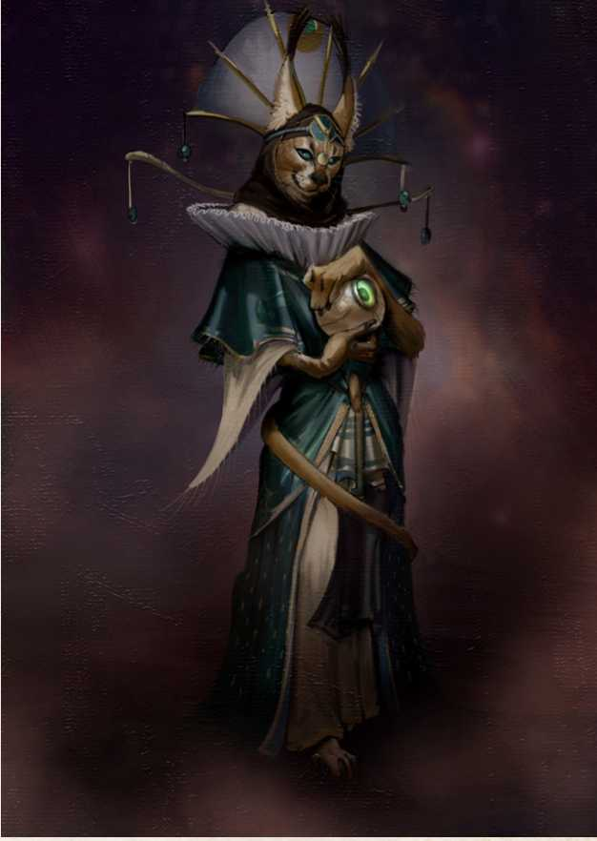You understand the aims of the Ordo and are now ready to participate actively in the life of the Faction. You are acknowledged to have developed and integrated into the society and culture of the Magi, and participate in local conclaves where your words are taken into consideration. The Faction now entrusts the you with more delicate tasks, and beside meeting important figures, you also gain basic knowledge of the world and magic through access to the Ordo’s magnificent libraries.

R*ANK 2 - MAQIS*T*ER*

***Fame earned in Faction to spend:*** 15

***Requirements:*** Take a novice under your wing and demon­strate that you can guide the future of newer generations of the Ordo.

You are recognized as Magisters while the protection and the eye of the Ordo also focus on their novices, even if it is still up to the Magi to understand the right moment to introduce their novices to the mysteries of the Faction. You may now participate in the Concilia Magistrorum, where the masters of the Ordo gather to discuss the future of theFaction, the developments in the field of Magna Ars and Alchemy, and the status of the world balance. Deeper se­crets are revealed to the Magisters: from the composition of the world and how history is and should be guided, to the obscure limits that must not be crossed and their possible

*RANK 4 - CONCLAVIST*

consequences.

***Fame earned in Faction to spend:*** 30

***Requirements:*** To be an enlightened advisor who occupies a prominent position in the society of the spellcasters of Vesteria, to have successfully trained valid novices, and to have demonstrated that you can ensure the future of the Ord ■.

You enter the Conclave of the Ordo Artis Occulta, the in­nermost circle of the Order where the Conclavists, gath­ered in secret, discuss the future of the Ordo, magic and the world, projecting plans for decades to come. Conclavists guard the secrets of the Order and choose which to erase from history and which to reveal to the world. They see themselves as custodians of the future and the past, and holders of the overall magical knowledge of the world; there is no mystery that escapes their eye. The deepest secret of the Ordo is kept in the bowels of Montetorto, where forbidden tomes speak of the very dark thing that caused a rift in the world and brought forth things that never should have emerged. Their very existence and the world they reveal risk upsetting the balance of power of the world; needless to say, many prying gazes scan the darkness in their direction...

A land like Vesteria offers a huge and intricate array of competing forces, and the best way to bring them into play is through Factions, power structures channeled into a growth pattern for characters to experience, ascending to personal and collective prestige: after all, the common goal of all the Factions of Historia is always power, in one form or another.

The GM and the players are left free to build their own factions if they feel the need to fill a void among those pro­posed or have an exciting idea they want to bring to the table. The Spies of the Black Master of the Confederation, the Duchy School of Winds Town, the Claw Society of Nidialti nobility or a dangerous band of rogues in the heart of the Green Pit forests, are just some ideas to create a new Faction and add a new pawn on the Vesteria power board. Each Faction shares a common scheme with the others and can be constructed in a simple way.

*OBJECTIVES*

Each Faction has a goal that pushes its affiliates to join its cause. It can be a material and achievable goal, or an ideal. The Objectives should be focused on drawing the Faction’s narrative in a specific direction, and Characters who choose to become members should at least partially share these Objectives to align their personal development with that of the newborn Faction.

The Objectives of a Faction also establish how Fame is collected by its members, and under which circumstances.

*FACTION LOCATIONS*

Locations, shelters, properties, and businesses are some ex­amples of places in which a Faction could reside and should be used as the hub of the game around which to build the story of the affiliated character. These places are excellent points from which to start adventures in the continent of Vesteria: from the missions entrusted directly by the Faction to actual safe areas to be used as a base for Characters’ actions and moveiiieiil.

*WHO CAN JOIN THE FACTION*

Not all candidates are ideal to enter a specific Faction, either for reasons related to the issues addressed, their ability to play, or the balance of the campaign. Characters should be com­fortable with the Faction context without getting frustrated at not being able to develop as hoped, and should decide to affiliate as members only if they fully adhere to its Objectives.

*HOW TO JOIN THE FACTION*

Joining a Faction should require conditions for which char­acters must consciously move towards that specific goal, demonstrating that they want to lead their roleplay experi­ence in that direction. Conditions to join should be specific, but not impossible, and within reach for the character. They represent simple indicators for characters who have made the choice to join the Faction.

*MANAQINQ CHARACTERS IN THE FACTION*

The importance of managing characters affiliated to a Faction revolves around the coexistence of their group of players with the Faction itself. It would be advisable to always in­sert conflicting elements that shift the focus on the choices that characters make and how their loyalty can swing from one extreme to the other, always remaining consistent with themselves.

*RANK 0 - ROOKIE*

***Requirements:*** The first requirement of any aspiring Rookie is to connect with the Faction, belong to a particular trade, pass an initial test and forge lasting ties with the Faction.

Rookies are like smaller cogs in the already well-oiled mech­anism of a Faction, which would work perfectly even without their presence. They start in the humblest of positions, and the tasks assigned to them are basic missions consisting in low-level labor aimed at testing their skills and their loyalty to serving the Faction. As long as characters remain in this Rank, their knowledge of the functioning of the Faction will remain cloudy at best.

*RANK 1 - MEMBER*

***Fame earned in the Faction to spend:*** 3

***Requirements:*** The requisite to become a full member usually involves confirming the premises made as a Rookie and hav­ing proven reliable to the Faction.

Members of a Faction constitute its backbone and are the most numerous and operational Rank, considered by many to be already more than enough for its running. Members

are seamlessly integrated into the Faction system and under­stand its underlying motivations and functioning. They do not take part in any decision making, but are given consid­eration by the higher Ranks and start receiving support and resources from the Faction for their work.

*RANK 2 - CHIEF*

***Fame earned in Faction to spend:*** 15

***Requirements:*** In addition to the hard work done to achieve the necessary Fame, the requirements to become a Chief in­volve having demonstrated skills and commitment above the average while fulfilling the tasks entrusted by the Faction, all without losing sight of methods and ideals.

Taking on the role of Chief in a Faction means strongly pursuing the goal of climbing its ranks. Consistency and dedication are needed, as well as a refined understanding of the functioning mechanisms underlying the Faction. This enables characters to enter its active part, make deci­sions, and model plotting on a personal basis. Chiefs are an indispensable resource and for this they receive great support and can count on all the resources that the Faction is able to provide.

*RANK 3 - INNER CIRCLE*

***Fame earned in Faction to spend:*** 30

***Requirements:*** To enter the Inner Circle of a Faction you need Fame, ambition, and above all the ability to lead: in short, having all the cards on the table to aspire to the top level of the Faction, whether in an attempt to conquer its summit or to inherit it at the right moment.

From the Inner Circle characters are able to touch the very foundations of the Faction and potentially reshape them ac­cording to their will. The Inner Circle modifies the behav­ioral pattern of all Faction members, and whoever has access to it is a figure of great notoriety and power even outside the Faction they belong to. The management of the Faction moves to a larger scale, and the resources available to char­acters are commensurate with what they can obtain or influ­ence thanks to their position of prestige.

***Special, Faction Privilege.*** Each Faction should grant its members some kind of special ability that can differentiate them from non-members. The weight of this privilege should change depending on the Rank at which it can be obtained and the Faction’s position of strength. It should always be something distinctive, but not something that can shift the balance of the game.



д$ЙСГб

CAREER DEVELOPMENT

*RANK 3 - SUPREME*

As with becoming members of a Faction, each character can try to engage in a personal project, creating their own path or career. Becoming the best sword wielder of Salso Nero, being considered the best Storyteller in the Holy Kingdom or becoming known as the Dark Hunter are all examples of careers focused more on one’s personal glory rather than that of the large number of members of a Faction. Nonetheless, careers also make use of the Fame resource.

In terms of the game, characters can build their own spe­cial Faction, a career, often closely related to the story and personality of the character themselves, in which they can invest Fame to represent their notoriety outside Factions. What follows is a list of some careers ready to be played, while the later part of the chapter provides instructions on how to set up your own custom careers.

*RANK 0 - DILETTAN*T*E*

* Requirements

*RANK 1 - PROFESSIONAL*

* Fame earned in Faction to spend: 5
* You gain:
* Coinage +10
* Resources Rank 1
* Equipment of Rank 1

*RANK 2 - ACCOMPLISHED*

* Specific requirements: Rank 1 in their careers
* Fame earned in the Faction to spend: 15
* You gain:
* Coinage +15
* Resources Rank 2
* Equipment of Rank 2

Specific Requirements: Rank 1 in your career

Fame earned in Faction to spend: 30

You gain:

* Followers of Rank 1 or 2
* Coinage +20
* Resources Rank 3
* Equipment for Rank 3



Artisanship is, together with agriculture, the economic heart of Vesteria. From the remote villages of the Green Pit to the courts of the most powerful metropolitan lords, every place lives off the manual labor of the people, be it at the service of small ideas or of great works. The nearby Rodelia remains the most shining example of what skilled hands can create, but the Continent too has been the birth­place of masters capable of winning the admiration of the most pretentious glances through their extraordinary cre­ations: blacksmith creations or magnificent shining jewels, impressive carpentry and innovative architecture.

*RANK 0 - APPREN*T*ICE*

***Requirements:*** Being introduced to the work of an artisan by a master to become an apprentice.

You are directed in a field of artisanship by a master, ob­taining proficiency in an artisan’s tool connected to the w 'ikshop.

*RANK 2 - MAS*T*ER*

You are a recognized artisan whose excellency is high in demand. Your works are sold at a higher than average price without this causing discontent among the clients or their trying to haggle for a lower price. Influential, powerful and wealthy people seek your work, often factions and large power groups. Thanks to your position as a master, you can now open their own shop and take on apprentices.

R*ANK 3 - EXCELLENCE*

Your style is easily recognizable in your work, becoming a signature of inimitable quality, although many try des­perately to copy it and get closer to its heights. You are a welcome guest in every prestigious environment and in every place connected to artisanship, from shops to acad­emies, even in royal courts and seats of power. Your works are among the best of Vesteria, and your experience endows the aristocratic quality to any work created.



*RANK 1 - CRAFTSMAN*

You have learned the basics of your field of artisanship, giv­ing value and higher quality to their work. The tool in which you have gained proficiency with your career becomes their preferred one, doubling your proficiency bonus when using ii.

***Special, Adaptable Handicraft.*** The knowledge you have ac­quired in the field of artisanship turns out to be useful in lateral activities, even ones unconnected to your proficiency. Once per session, when you spend inspiration to gain ad­vantage on a roll, you can also apply youry craft knowledge to a problem or situation not directly related to their field, adding the proficiency bonus granted by their favorite item to the roll - as long as they provide a roleplay explanation that satisfies the GM. If you were already proficient in that roll, you do not stack the two bonuses but have the oppor­tunity to choose which bonus to apply.





Art is an important part in the life of the inhabitants of Vesteria: whether sacred painters in the pay of the Church of Bones in the Holy Kingdom, the actors who tread the stages in Salso Nero, or the favorites of the patrons of the Confederation, there is always great demand for talent and desire to enjoy the fruits produced by the arts. An art­ist has the choice of infinite fields in which to specialize, from the traditional schools of painting and sculpture to the virtuous stages of dance or music, as well as any oth­er discipline through which artistic sensitivity can convey emotions to people.

R*ANK 0 - APPREN*T*ICE*

***Requirements:*** Being introduced to the work of an artist by a master to become an apprentice.

You embark on the desired artistic path and obtain profi­ciency in a musical instrument or in an artisan’s instrument connected to it, guided by a master who advises and in- slru.ls you.

R*ANK 1 - ARTIST*

You begin to gain wealth from your performances or cre­ations, starting to gain Fame as a professional in the sector and separating from your mentor.

***Special, Impress with Art.*** Your artistic skill allows you to create works that, in addition to guaranteeing an economic income, help you to increase your Fame. Each time you per­form or create a work of art, you can try to impress someone present at that moment and with a higher Fame than yours through a check related to your artistic field with difficul­ty decided by the GM depending on the situation. If suc­cessful, each time you acquire Fame with a specific activity of your career, you gain additional Fame for each NPC of higher fame who was present at that moment and whom you were able to impress.

*RANK 2 - RECOGNIZED*

You are a sought-after and well-liked artist in any envi­ronment where your art can be appreciated, and have an advantage on social interaction checks with those belong­ing to these circles and who are admirers of your work. Additionally, you are considered a master of your discipline and can instruct apprentices.

*RANK 3 - FAMOUS*

You have reached the highest artistic peak in your field, joining the ranks of artists who have gone down in history. On reaching this level of experience, you are now able to influence the judgment of the powerful and start new fash­ions. Once per session, you can spend inspiration to change, for a short period of time at the GM’s discretion, the com­monly held idea about any element, item or thought in soci­ety, making it a popular or particularly despised trend.



Exploration is one of the founding stones of Vesterian so­ciety. Whether by land, water or sky, charting the best trade routes, opening new passages, or discovering new mineral resources in uncharted territories, exploration is part of the vibrant life of the people of the continent. For this reason, the art of representing accurate and precise maps is held in the highest regard. If pursued, it is a very renowned ca­reer and the best and most famous cartographers become members of courts and palaces, participate in competitions held by local lords, or travel with the most important com­mercial enterprises.

R*ANK 0 - AMA*T*EUR*

***Requirements:*** Finding a cartographer willing to initiate the character in the art of mapmaking.

You begin yourwn journey in the world of cartography, ac­quiring proficiency in the tools of a cartographer and are encouraged to explore as much as possible of the conti­nent to practice detailed reproduction of its geography and lejiuivs.

*RANK 2 - EXPLORER*

Your Fame as a professional cartographer is now well known in a wide area and people ask you for advice. Furthermore, once per session, drawing from among your contacts, acquaintances and past research, you have the op­portunity to find a map of a particular area or building. Moreover, your notoriety and ability make your work pre­cious: your maps are considered real works of art and are requested to appear in the best parlors and by the most powerful and wealthy socialites.

R*ANK 3 - PIONEER*

You have now gained experience of places so remote to only be known to others as distant legends. No matter whether the maps were drawn on-site or from the tranquility of your workshop, still they are so evocative and precise of the plac­es indicated to represent true and inimitable masterpieces in terms of style and content. Maps prepared by the you are of such high quality that they grant advantage on Nature, Survival and History checks on the spot for the viewer and can be of great advantage in case of battle.



*RANK 1 - CARTOGRAPHER*

You have learned some tricks of the trade and know how not to be caught unprepared: you have memorized a good number of maps and can understand where you are pre­cisely in a matter of minutes through observation of your surrondings. You also begin to have some success in selling iheH I'V' dll.l-.

***Special, Art of Maps.*** You always have at hand the necessary equipment to draw up a map of the surroundings and the routes you take, even with makeshift means. This makes it virtually impossible for you to lose their way, unless super­natural circumstances occur...





History is written by the winners, who shape it in their own image and likeness, and it is the mirror of facts accounted for by the pen of those who report them. Being a success­ful Historian in Vesteria means being a master of how the world will remember the events of yesterday and explain the situation today. This delicate work is constantly caught in the balance between facts and opinions: an objective history can never be presented but a reliable one, perhaps. Historians who set themselves the task of reporting facts will have to choose which truth to lean towards, and wheth­er to let academic or personal interest prevail.

R*ANK 0 - CHRONICLER*

***Requirements:*** Ability to read and write, proficiency in history.

You travel through the lands of Vesteria to keep track of the most significant events that animate the continent. Whether at the service of a noble, an institution or an intellectual free from constraints, a chronicler is driven by the curiosity to fully discover the wheels that move the great mechanism of history. You gain proficiency in calligrapher’s tools.

R*ANK 1 - HISTORIAN*

You are recognized as having such skills in writing events to be considered a reliable and respectable source. During your travels you can always find refuge from local nobles and are recognized as a neutral authority, free to observe the world and bring it to life in your writings. Historians double their proficiency bonus on History checks.

***Special, Writing History.*** You are a skilled writer, capable of telling historical events with passion, glorifying its protago­nists. During a long rest, you can spend your time redacting the records of events involving yourself, earning your com­panions who have accumulated Fame since the last time this task was taken up, an additional Fame point for each career rank.

*RANK 2 - CRI*T*IC*

You are recognized for your judgment on events and for your great knowledge of how these are part of a cycle of very specific causes and effects and are therefore sought after as an advisor, listened to with great attention. You are always well received in the higher circles and receive hospitality as welcome guests even in territories that are hostile to your place of origin. You can use your History skill to persuade someone on matters of political or stra- leglc advice.

R*ANK 3 - CANTOR*

When narrated by yourself, history rises to a poem appreci­ated throughout the continent. Your role as an independent authority is protected by treaties of immunity. Hosting you in one’s own estates is considered an honor and is disputed among the greatest protagonists of power in the whole of V e-ieri.i.



Knowledge is power, especially in a world where knowledge can be the only way for some to raise one’s life from a mis­erable and desperate condition to a position of prestige in society. If accumulated culture and knowledge were to van­ish along with those who cultivated them, the world would have to start all over again, inevitably becoming unable to progress as far. For this reason and to ensure its develop­ment, the most noble of occupations is that of mentoring, sharing knowledge with the world and entrust it to students who will in turn be equipped to progress it further.

R*ANK 0 - S*T*UDENT*

***Requirements:*** Knowing how to read and write, have a cul­tural background and academic support.

You are initiated to a field of study, with the support of a mentor or a cultural institution such as an academy, library or court. Students not only research purely theoretical or ac­ademic subjects or study out of thirst for knowledge alone; truly, they are also driven by the desire to be able to one day pass on this knowledge. How you approach your stud­ies confers you proficiency in a skill chosen from Arcane, Investigate, Nature, Religion and History as well as in an Jflis.in lool.

R*ANK 1 - INSTRUCTOR*

You now see their academic commitment recognized, even economically, and have furthered your study to the point of being able to teach the basics to other students. The tutor or institution supporting you directs you to divide your time between research, study and teaching. You can choose from the skill and the tool gained with the career and double their proficiency bonus on related checks.

***Special, Understanding and Explaining.*** You have excel­lent understanding and memory skills and are able to eas­ily transfer knowledge. Once per session, when you spend inspiration to gain advantage on a roll, you can choose to use Intelligence or Wisdom as a reference trait, even if the ability doesn’t provide it. You can also spend a hit die to explain something to another character: until the end of the next rest, a character who has been taught a lesson gains proficiency in a skill in which the master is proficient. You can use this ability once per career Rank per long rest.

R*ANK 2 - PROFESSOR*

*YOU HAVE BECOME A KEY FIGURE WI*T*HIN* academic institution to which you are connected and are recognized as a leading expert in your field. You a re a prominent figure in high cultural environments and are sought out as an advisor by wealthy or powerful people for your in-depth studies. Several teachers serve you as assis­tants and academia grants you access to the most disparate sources of knowledge. Professors always know where to find information or who to contact to retrieve it.

R*ANK 3 - DEAN*

Characters are the heads of the academic institution that supported them and that they now lead, becoming responsi­ble directors for classes, students and academic services. Your name is engraved in history and counted among the greatest geniuses and sages of your time, guaranteeing you respect and honor on par with the most powerful figures of Vesteria.



Since civilizations and societies have existed, power has al­ways had to be harnessed in well-coded schemes, laws and practices. Politics is the art of power management: paint­ing alliances, sculpting edicts, singing praises and acting with a mask. In Vesteria, where power is the most coveted object, politics is a ferocious, violent, devious and strategic art, which requires finesse, wit and charm. Entering the whirlwind race of politics is as intoxicating as it is danger­ous, but it is a necessity that drives some to get involved: after all, every puppet show needs a master puppeteer to I pull the siriiigs.

R*ANK 0 - MINION*

***Requirements:*** Gaining the trust of an official and being in­troduced to political office.

You perform simple tasks and jobs on behalf of senior offi­cials, slowly being introduced to the complicated and subtle mechanics of politics and gaining the opportunity to learn the tricks of the trade. You may choose either Persuasion or Deception; if you have no proficiency in the chosen skill, you gain it, otherwise you add an additional half of your proficiency bonus to checks relying on that skill.

R*ANK 1 - OFFICIAL*

You gain political responsibilities, albeit initially at low Rank. You can occupy important positions in small offices or minor positions in a more prestigious environment, always responding to more important superiors while entering into contact with the most influential authorities in your area, and with the various powers, political and otherwise, that gravitate around them. Once reaching the rank of Official you consider your career, including any future Ranks ac­quired, tied to a particular political faction. Where narrative conditions allow, characters can switch their political side and with it the origin of their privileges and resources.

***Special, Redeem Favors.*** In politics there is always a credit to be collected, an eye to close, or a favor to redeem. Once per session, you can spend inspiration to ask for a favor to be “returned”: this causes the intervention of an NPC with a rank equal to that of the Official, and who has resources and skills to help the you within the limits deemed appro­priate by the GM. This feature can function like the villain’s “Part of the Plan” ability, triggering a flashback scene.

*RANK 2 - ADMINISTRATOR*

Administrators are persons of great influence in their own political environment of reference, where they have reached positions that make them important protagonists. You have attracted the most diverse contacts from every walk of life, each with interests that potentially rest in your hands. Politicians always have many friends in the open and many enemies in the shadows; they truly fear failure and can lose everything in the blink of an eye. Despite the risks associated with this career, the privileges they can win are unmatched.

R*ANK 3 - GOVERNOR*

You have arrived at the top of the political ladder, reaching a position of maximum control and power: you are part of a council or parliament of great importance, administrators of an important city or region, and can potentially aspire to the leadership of an entire nation. Your name is known everywhere in Vesteria, you have resources well above the average and can speak as peers to the most powerful and influential political players in the whole country.



A cruel world creates cruel lives, and with its contradictions, abysmal social differences and power games, Vesteria is de­cidedly ruthless. Those who do not want to bow to harsh and oppressive laws or seek profit through illicit trades, irreme­diably end up becoming outlaws, consigning themselves to a life of crime. There is no shortage of evil and merciless people at least as much as the world they inhabit, villains who follow this path out of pleasure or sheer desire for wealth and power, without scruples or ever stop to ponder about the “absurd” limits posed by the law. Various criminal organizations bring these outlaws together, potentially becoming able to stand up to ‘regular’ factions and official bodies.

R*ANK 0 - SCUM*

***Requirements:*** Committing a crime.

You have chosen to continue on the path of crime after hav­ing committed a crime. You begin to make contact with other petty criminals and the like, hiding from the law, which earns you proficiency in camouflage or disguise tricks.

R*ANK 1 - OU*T*LAW*

You are now sought after and determined to continue on the path of crime: you join an organized group of outlaws or find fellow criminals with whom to create an alliance, exchange information, protection and proceeds from illegal activities. You gain a proficiency chosen from rogue tools, poisoning gear or a play set.

***Special, I know a guy.*** You always know a representative of some criminal gang who has the skills or resources neces­sary to overcome an obstacle and be useful for some specific job. Once per session, you can spend inspiration to treat a number of NPCs equal to or lower than your Career Rank as minions until the end of the task, in agreement with the GM. The rank of these followers must be lower than the career rank of the outlaw.

*RANK 2 - CRIMINAL*

You have earned quite some Fame in the underworld, to the point where you are now known even by ordinary people and the authorities. Your criminal Fame has brought several other outlaws to follow your lead, or maybe you have climbed the ranks of the organization to which you are affiliated.

R*ANK 3 - BOSS*

You now direct the shady operations of an entire criminal or­ganization and are feared and recognized as the most evil of outlaws on the entire continent. Your position puts you in the particular situation of having to be accepted by high society and politics, being by now too dangerous to be ignored, never ШШН st .|>|>,',|.

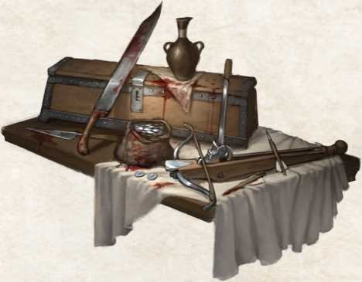

In a peninsular continent like that of Vesteria, with three sides bathed by the sea and the fourth closed by an impos­ing mountain range, navigation has always been of funda­mental importance for trade and travel. The call of the sea has always attracted the inhabitants of both sky and land, pushing them towards the adventurous unknown with all of its risks and rewards: while sailing, many have found luck, but far more have lost everything. Sailors cannot re­sist the call, driven as they are by their heart or by the mere need to earn money.

R*ANK 0 - CABIN BOY*

***Requirements:*** To be accepted aboard a ship.

You begin your adventure at sea by carrying out the hum­blest tasks on the ship. In addition to working on or below deck, finding some sort of leisure while sailing is important in order to lighten the time spent on sea. For this, you gain proficiency in a game and, every time you win in that game (whether cheating or not) they gain inspiration.

R*ANK 1 - SAILOR*

You have gained experience at sea and now occupy a de­fined role among the crew. In addition to having earned the respect of the crew, you have gained mastery of seafaring jargon and the habits of life at sea. You gain proficiency with navigational tools and have an advantage in using, ty­ing or securing ropes, thanks to your knowledge of seafaring knots.

***Special, Fortune of the Sea.*** If you are at sea or on a ship, when you roll a 1 on any die roll, you can roll again and keep the second result. You can use this ability a number of times per long rest equal to your career rank.

*RANK 2 - BOATSWAIN*

You have become one of the ship’s officers and have a role of great responsibility dealing with the management of crew­members and resources. Your name has traveled the seas as much as the ship you sail, reaching ears near and far. You have at least one contact in each port of Vesteria and gain a spyglass as a symbol of their status.

R*ANK 3 - CAPTAIN*

You have earned the right to command a vessel and your Fame has crossed the sea, reaching even territories far from the coasts where you usually set sail. Only the wealthiest can afford your services (unless yours have chosen... “alter­native” approaches, such as piracy) and your exploits blend with legend in the stories told on the piers or inside harbor inns: each time you gain Fame through feats performed at sea, they gain 1 additional Fame point.



Vesteria is a continent split and wounded by war, where life can be very harsh and conflicts of power are the only inter­ests pursued by the rulers. In this scenario, the great powers accumulate war resources through a continuous arms race, which weighs on the people with cruel taxes and strong restrictions. The powers that be also try to constantly in­crease the number of soldiers in their service in order to vanquish opposing forces. The life of a soldier is hard, full of sacrifices and probably short-lived, where only the most valid fighters are able to transform what could be a death sentence into a fruitful trade, refining weapons and war skills and conquering their own space in the world through strength and determination.

R*ANK 0 - RECRUIT*

Requirements: Proficiency in a martial weapon, registering with an enlistment office.

You have joined

a military organization, whether it is a mercenary group or a regular army. Your commitment and devotion lies with the organization you have joined, in which you are deployed among the reserves and trained in the art of war. You gain proficiency in an artisan tool and in the Survival skill.

R*ANK 1 - SOLDIER*

You are trained in weapons and their use on the battlefield. You are now part of the regular troops and are deployed on the battlefield or on a mission as needed. You gain a profi­ciency of their choice among use of a weapon, armor type or shieldand if you are already proficient in all weapons, armor and shields you can choose a weapon to become your favor­ite, adding an additional half of your proficiency to the hit r 'll when Hsing- II.

***Special, Warrior Life.*** You live to fight and fight to live. Whenever you gain Fame through the use of weapons and warfare skills, you gain 1 additional Fame point per career rank.

*RANK 2 - OFFICIAL*

You are now a recognized officer who occupies one of the highest ranks within the military, issuing orders and man­aging troops and resources.

Your rank is also recognized outside of your military orga­nization, making you fit into even the most sophisticated en­vironments. You gain access to aristocratic weapons and armor.

R*ANK 3 - COMMANDER*

You are now in command of the military organization in which you serve, placing yourself in a delicate and danger­ous position, albeit one of great power. Governors must take into account your ideas and moods, as you will often be- employed as a strategic advisor and involved in the political management of the country or organization to which the army is tied. In addition, you will gain an exceptional weap­on with a +2 bonus.

